Group 23 (Adam Preston, Euel Domingo, Marcus Robinson-Bailey, Kester Gideon)

CO600  University of Kent

Web Page Design and Documentation

# Introduction

The purpose of this document is to provide information regarding on the one-page website which is the user interface for the Terms and Conditions Analyser. It will talk about the design and functionality and how it meets the purpose of the website.

# Purpose

The goal of the web page is to allow users to review the terms and conditions they want to analyse. The website will have a text area where users can paste a copy of the terms and conditions to the text area. After adding the text to the text area, there will be a button called ‘Analyse’ where the website will send the document to a server for analysis. Finally, when the server successfully analyses the document, it will return a list of risky statements and the website will display the list to the user.

# Layout and Formatting

## Theme

The design of the webpage will be created from a template ‘Miniport’ taken from <https://html5up.net/>. The template provides the fundamental design and functionality needed for the website. The only changes needed will be the content such as the headers, text and images.

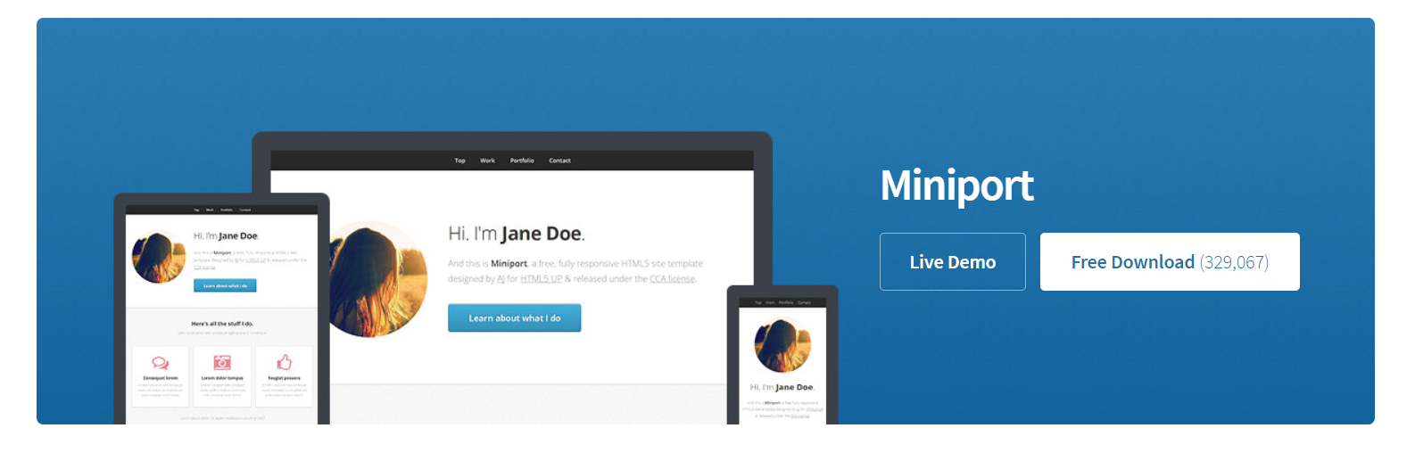

The colours that will be used for the website are:

* White for the background
* Shades of Light and Dark Grey which will be used mainly for background and text.



* Blue mainly for the buttons.



## Layout

The navigation will always stay visible on top of the page.

Navigation

Interface

* Text area
* Analyse Button
* Clear Button

System Highlights

Heading

Logo

# Technology

* HTML
* CSS
* JavaScript
* Ajax
* jQuery

The Ajax developed in the website handles the communication between the client (i.e. website) side and the server (i.e. Classification Algorithm API) side. The main goal of this technology is to establish connection with the server, send the document in the correct format so that the Classification Algorithm API running on the server can process it and reads the data returned by the server. The technology can also catch errors if a user inputs incorrect data.

# Functionality

Users will need to copy the Terms and Conditions and paste it to the text area. A copy means selecting or highlighting the terms and conditions, and triggering ‘Copy’ (i.e. pressing Ctrl+C).

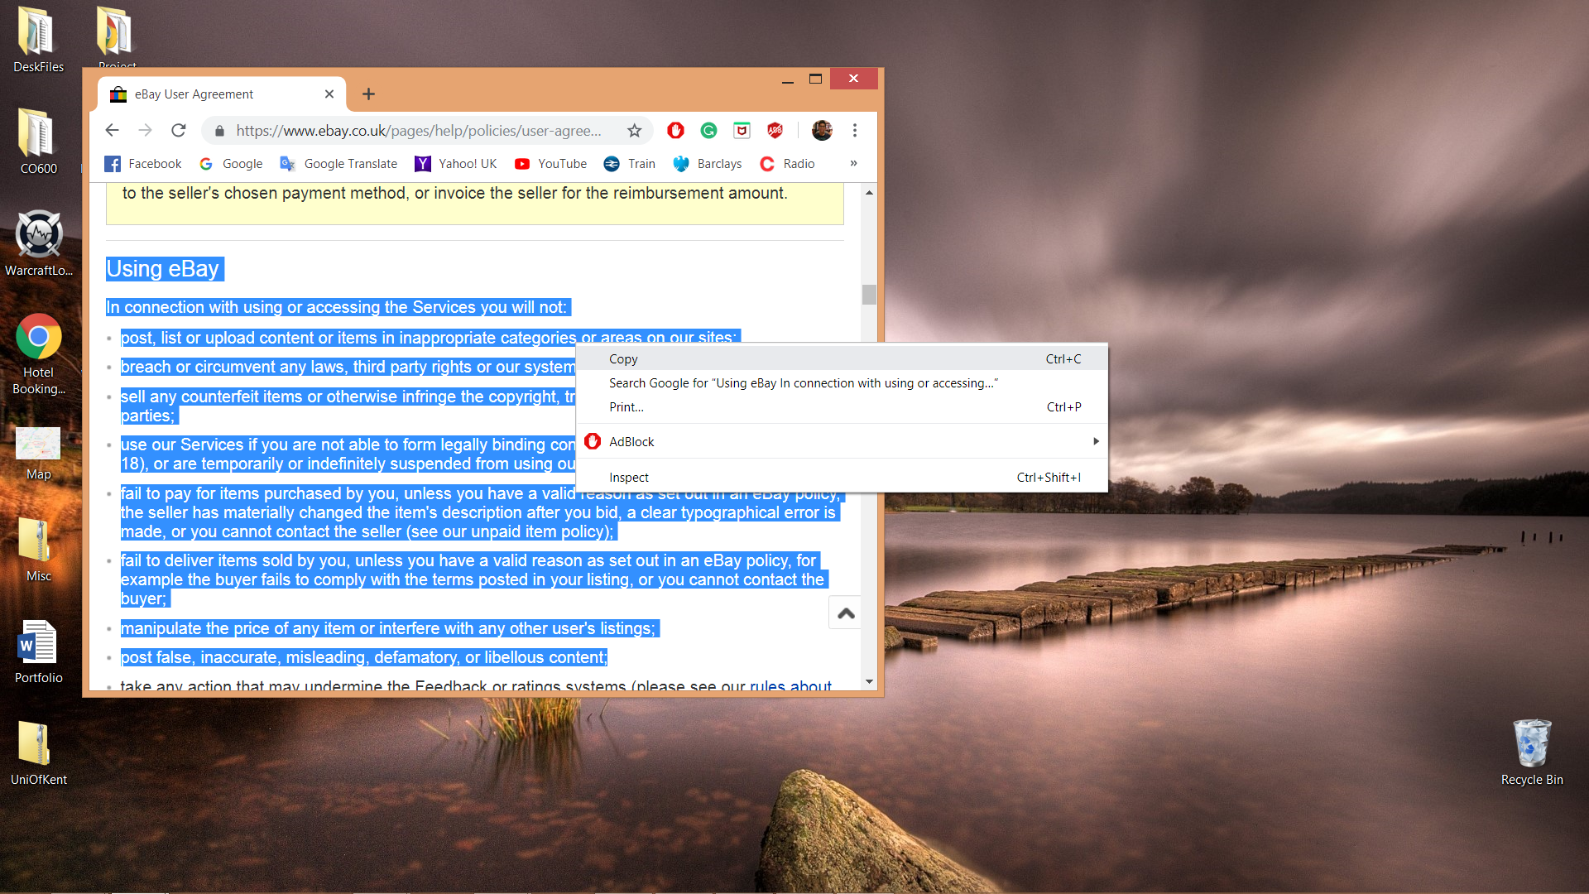

When the user has a copy of the document, they will need to paste it onto the text area (i.e. clicking the text area and then pressing Ctrl+V).

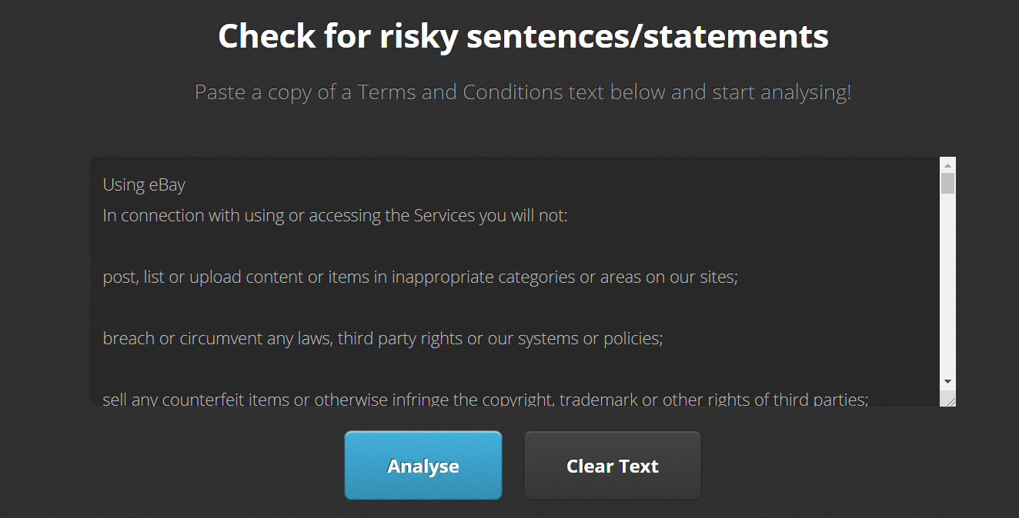

After the user has pasted the terms and conditions onto the text area, they should press ‘Analyse’ button so the website can send the copy to a server which is running the system that will analyse the document. After the document has been analysed, it will display to the user a list of risky statements found in the document.

